**PROJECT PROPOSAL**

**OF**

**PERFORMANCE EVALUATION SYSTEM**

**For**

**TRANS-MERCH APPAREL PVT LTD**

**KADAWATHA**

**IMGT 3†34**

**Design & Development of Computer Based Project**

Submitted by

Name: A.M.M.M.Abeysinghe

Reg No: 142033

First Supervisor: Dr. (Mrs) W.G.E.J.Wattegama

Second Supervisor: Ms.E.A.C.Dilrukshi

Department of Industrial Management

Faculty of Applied Sciences

Wayamba University of Sri Lanka

Date of submission: 31st of March 2017

CONTENTS

1. INTRODUCTION 1

1.1 Organization 1

1.2 Project 1

2. IDENTIFIED BUSINESS PROCESS 1

2.1 Explanation of the Selected Process 2

2.2 Details of the System Boundary 3

3. AIMS AND OBJECTIVES [PROJECT] 3

5. PROBABLE SOLUTIONS TO OVERCOME THE ISSUES AND SATISFY THE CLIENTS 4

7. PROJECT FEASIBILITY 5

8. PROJECT SHEDULE 6

9. CLIENTS’ CONTACT DETAILS 6

# 1. INTRODUCTION

## 1.1 Organization

Trans-Merch Apparel Pvt Ltd was established in Toronto, Canada in 2006 as an apparel manufacturing and design company. They manufacture and distribute to all leading customers across North America. Furthermore they have strategic partnerships with Walmart, target, Sears and Bay Company. They own and operate manufacturing and distribution locations in Toronto, New York and Sri Lanka.

The Sri Lankan branch of Trans Merch Apparel pvt Ltd was established in Kadawatha in 2015.07.02. The current owner of the organization is Mr. Welayudan Ilangeshwaran Currently about 126 workers are working there under 3 managerial levels.

## 1.2 Project

This system will be developed and submitted in fulfillment of the requirements for the course module, IMGT 3+34, for the “B.Sc. (Joint Major/Special) Degree” offered by the Faculty of Applied Sciences in Wayamba University of Sri Lanka.

Currently all the functions of the performance evaluation are done manually to some extent. The proposed system suggests a well-organized computer based process for current operations. Main objective of the design and development of the project is to make the organizations’ selected process more efficient and productive.

# 2. IDENTIFIED BUSINESS PROCESS

Trans-Merch Apparel execute the following operations.

* Planning
* Cutting
* Production
* Packing
* Stores
* Finance
* Human resource management
* Mechanical operations

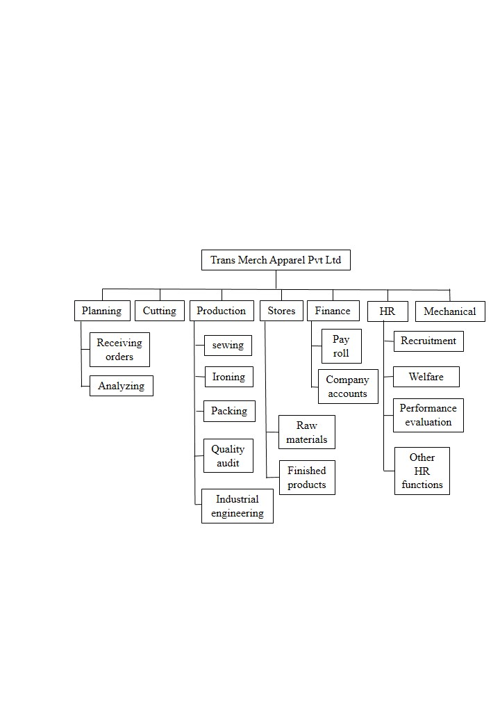

## 2.1 Explanation of the Selected Process

From the whole business process, performance evaluation of the factory workers of Trans-Merch Apparel Pvt Ltd, is selected for this project. That is under the Human Resource department of the company. Some of the functions under performance evaluation are as follows.

* Recording attendance - An attendance sheet is given to the factory workers to sign daily and then it is sent to the HR department.
* Calculating overtime hours - Another signing sheet is given to the overtime workers during overtime hours.
* Quality audit - Items are checked by the quality auditors to find the faults in them. Also they are maintaining quality levels in each process of the system
* Incentive plans - The workers are provided individual, group and organizational incentives according to their performance.
* Discipline management - Normally discipline of each worker is observed by their supervisors and recorded. Some of the criteria they are using to observe the discipline are prohibited behavior rules, punctuality, respecting the managers and etc.

I am willing to introduce a more user friendly and accurate computerized performance evaluation system to their organization. Also I hope to implement more accurate report generation procedure for the system to make it easier for usage.

## 2.2 Details of the System Boundary

Evaluate the performance of factory workers.

There are various types of factory workers in the company under different sections. They are,

* Cutting section - Cutting helper, Cutter, Cutting supervisor
* Production section - Machine operator, Helper
* Packing section - Packing helper, Ironer
* Stores - Store keeper, Store assistance, Store helper

The system boundary contains following things.

* + Employee attendance
  + Overtime payment
  + Cost per unit
  + Incentives based on performance
  + Number of units produced at a particular time period
  + Number of defective items produced at a particular time period
  + Quality of the products
  + Time taken to finish a given task
  + Cooperation among workers

# 3. AIMS AND OBJECTIVES [PROJECT]

* Measure the performance
* Identify training needs of employees
* Increase efficiency
* Reduce paperwork
* Cut off cost
* Create a user friendly system for the organization
* Proper handling in all included activities
* Maintain more sincere relationship between the factory workers and managers
* Management of technology to obtain the maximum utilization of available resources
* Help the government mission of IT literacy enhancement

**4. PROBLEMS AND WEAKNESSES OF THE CURRENT SYSTEM**

* The performance evaluation system is done some extent to manually at the moment
* The company has to keep separate files for enter some performance evaluation information
* Employees has no clear idea on what they can expect from the company
* Keeping document files requires some space
* Threat of losing and decay of originals of documents
* No tool to identify the weaknesses of the performance evaluation
* High material wastage

# 5. PROBABLE SOLUTIONS TO OVERCOME THE ISSUES AND SATISFY THE CLIENTS

* Improve the current manual system
* Create a manual system with simple computer based system
* Create a fully computerized database system to handle data about performance evaluation to replace the manual system
* Because of the database created, the data will be stored in order and it will be easy to access the relevant data
* Records from the each and every step of the performance of the factory workers will be saved and can be used to evaluate their performance
* Reduce the time consuming by the automated Performance evaluation system

**6. BENEFITS AND ADVANTAGES OF COMPUTERIZATION**

* Support for the management by providing information timely
* Support for the management to identify the weaknesses of the current manual system
* The organization can expand their business and increase their performance
* The organization can minimize the cost for paper work
* Improve the efficiency of the service and save time
* Accuracy of the information can be increased
* Easy to operate
* Past details can be analyzed.

# 7. PROJECT FEASIBILITY

* Financial Feasibility

Management of the Trans-Merch apparel pvt ltd is willing to grant funds for this project as it supports to measure and increase their performance in an easy way. Also it’s a cost effective and efficient in long term when compared to their current manual system. They are very positive and have no hesitation for it.

* Operational feasibility

The management of the company is willing to recruit employees to handle the automated performance evaluation system.

* Technical feasibility

Currently the organization is using computers. Therefore they possesses enough facilities which are needed in computerizing the performance evaluation system.

* Human factor feasibility

The employees who need to work with this computerized system have the basic knowledge about computers. It will be easy to evaluate their performance more conveniently with this system

# 8. PROJECT SHEDULE

|  |  |  |  |  |  |  |  |  |  |  |  |  |  |
| --- | --- | --- | --- | --- | --- | --- | --- | --- | --- | --- | --- | --- | --- |
| Project Activity | | Duration  (months) | Month | | | | | | | | | | |
| March | April | May | June | July | August | September | October | November | December |
| 01 | Feasibility  study | 01 |  |  |  |  |  |  |  |  |  |  |
| 02 | Requirement  analysis | 02 |  |  |  |  |  |  |  |  |  |  |
| 03 | Requirement  specification | 02 |  |  |  |  |  |  |  |  |  |  |
| 04 | Meeting the client | 09 |  |  |  |  |  |  |  |  |  |  |
| 05 | Physical design | 02 |  |  |  |  |  |  |  |  |  |  |
| 06 | Programming & construction | 05 |  |  |  |  |  |  |  |  |  |  |
| 07 | Testing | 03 |  |  |  |  |  |  |  |  |  |  |
| 08 | Report writing | 09 |  |  |  |  |  |  |  |  |  |  |
| 09 | Installation | 01 |  |  |  |  |  |  |  |  |  |  |

# 9. CLIENTS’ CONTACT DETAILS

Address: Trans-Merch Apparel Pvt Ltd.

70/1,

Malwatha Mawatha,

Kadawatha

Mobile: 071 8375996